**Exp 06: Demonstrate virtualization by Installing Type-2 Hypervisor in your device,**

**create and configure VM image with a Host Operating system (Either**

**Windows/Linux) using virtual box**

**Aim**

To install a Type-2 hypervisor (Oracle VirtualBox), create and configure a Virtual Machine with **1 CPU, 2 GB RAM, and 15 GB storage**, and install a guest operating system (Ubuntu/Windows) on the virtual machine

**Procedure**

1. Install VirtualBox on the host machine (Windows/Linux) and ensure virtualization (Intel VT-x / AMD-V) is enabled in BIOS/UEFI.
2. Launch VirtualBox and create a new Virtual Machine, specifying the OS type and version.
3. Allocate hardware resources – set 2048 MB RAM and 1 CPU for the VM.
4. Create a Virtual Hard Disk of 15 GB (VDI, dynamically allocated) for the VM.
5. Attach the OS ISO file to the VM’s optical drive and start the VM to install the guest operating system.
6. Complete OS installation and install Guest Additions to enable smooth display, clipboard sharing, and better performance.

**Output**

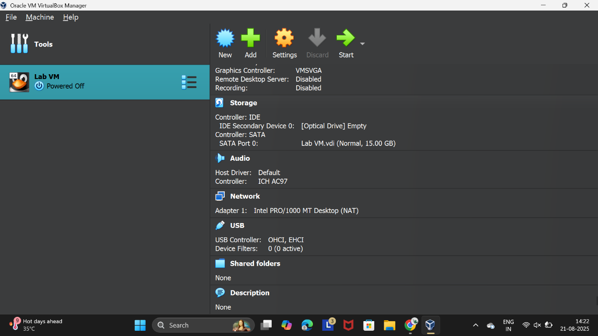

Figure 1 Virtual Machine with 1 CPU, 2 GB RAM, and 15 GB storage

**Result**

A Type-2 hypervisor (VirtualBox) was successfully installed on the host machine. A Virtual Machine was created with the configuration **1 CPU, 2 GB RAM, 15 GB storage**, and a guest operating system (Ubuntu/Windows) was installed and executed successfully.